RATNAM HIGH SCHOOL
+(91)-8622-20449
PATUR ROAD, KOVUR, SPSR NELLORE
Date : 06-01-2019
FEE CERTIFICATE

This is to certify that the following student has been studying 2nd Standard Since the academic year 2018-2019 in this institution he / she has paid the tuition fee as follows.
Name of the Student | Guardian Name | Term | Tuition Fee Amount
M.Medha | Narasimhulu U | Ist | 9,000
M.Medha | Narasimhulu U | IInd | 9,000
M.Medha | Narasimhulu U | IIIrd | 9,000
M.Medha | Narasimhulu U | IVth | 9,000

Thirty Six Thousand Rupees Only/-

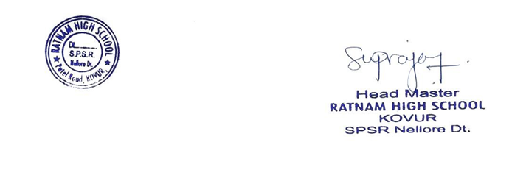

No.56, A.C.Nagar, Kovur, Nellore - 524137.
(Behind B.C.K.C Kalyana Madapam)

